UNITED STATES
SECURITIES AND EXCHANGE COMMISSION
WASHINGTON, D.C. 20549

FORM 8-K

CURRENT REPORT
Pursuant to Section 13 or 15(d)
of the Securities Exchange Act of 1934
Date of Report (Date of earliest event reported): September 8, 2026

BridgeBio Oncology Therapeutics, Inc.
(Exact name of Registrant as Specified in Its Charter)

Delaware |  | 001-41955 |  | 39-3690783
(State or Other Jurisdiction  of Incorporation) |  | (Commission  File Number) |  | (IRS Employer  Identification No.)
256 E. Grand Avenue, Suite 104
South San Francisco, CA 94080
(Address of principal executive offices, including zip code)
(650) 405-4770
(Telephone number, including area code, of agent for service)
(Former name or former address, if changed since last report.)

Check the appropriate box below if the Form 8-K filing is intended to simultaneously satisfy the filing obligation of the registrant under any of the following provisions:

☐ | Written communications pursuant to Rule 425 under the Securities Act (17 CFR 230.425)

☐ | Soliciting material pursuant to Rule 14a-12 under the Exchange Act (17 CFR 240.14a-12)

☐ | Pre-commencement communications pursuant to Rule 14d-2(b) under the Exchange Act (17 CFR 240.14d-2(b))

☐ | Pre-commencement communications pursuant to Rule 13e-4(c) under the Exchange Act (17 CFR 240.13e-4(c))
Securities registered pursuant to Section 12(b) of the Act:

Title of each class |  | Trading  Symbol(s) |  | Name of each exchange  on which registered
Common Stock, par value $0.0001 per share |  | BBOT |  | The Nasdaq Global Market
Indicate by check mark whether the registrant is an emerging growth company as defined in Rule 405 of the Securities Act of 1933 (§230.405 of this chapter) or Rule 12b-2 of the Securities Exchange Act of 1934 (§240.12b-2 of this chapter).
Emerging growth company ☒
If an emerging growth company, indicate by check mark if the registrant has elected not to use the extended transition period for complying with any new or revised financial accounting standards provided pursuant to Section 13(a) of the Exchange Act. ☐

Item 8.01 | Other Matters
On September 8, 2026, BridgeBio Oncology Therapeutics, Inc. (the “Company”) issued a press release titled “BBOT Announces New BBO-8520 Data; Highlights Strategic Focus on 2L+ NSCLC BBO-8520 Combination as Well as BBO-11818 and BBO-10203 Combinations in KRAS-Mutant Cancers.” A copy of the press release is attached as Exhibit 99.1 to this Current Report on Form 8-K and incorporated herein by reference.
Also on September 8, 2026, the Company revised its Corporate Presentation in connection with recent corporate updates, a copy of which is being filed as Exhibit 99.2 to this Current Report on Form 8-K and incorporated herein by reference.

Item 9.01. | Financial Statements and Exhibits
(d) Exhibits

Exhibit No. |  | Description
99.1 |  | Press Release dated September 8, 2026.
99.2 |  | Corporate Presentation updated as of September 2026.
104 |  | Cover Page Interactive Data File (embedded within the Inline XBRL document).

SIGNATURES
Pursuant to the requirements of the Securities Exchange Act of 1934, the registrant has duly caused this report to be signed on its behalf by the undersigned thereunto duly authorized.

 |  |  |  |  |  | BRIDGEBIO ONCOLOGY THERAPEUTICS, INC.
Date: September 8, 2026 |  |  |  | By: |  | /s/ Pedro J. Beltran, Ph.D.
Name: Pedro J. Beltran, Ph.D.
Title: Chief Executive Officer
Exhibit 99.1


BBOT Announces New BBO-8520 Data; Highlights Strategic Focus on 2L+ NSCLC BBO-8520 Combination as Well as BBO-11818 and BBO-10203 Combinations in KRAS-Mutant Cancers

 |  |  | BBO-8520 plus pembrolizumab demonstrated a 75% ORR at 500 mg QD and 53% ORR across dose levels in 2L+ KRASG12C inhibitor-experienced NSCLC patients

 |  |  | BBO-8520 monotherapy continues to show highly competitive ORR in the 2L+ KRASG12C inhibitor-naïve NSCLC with ORR of 63% (26/41), disease control rate (DCR) of 100% (41/41) and no grade 3 liver enzyme elevations

 |  |  | BBO-11818 and BBO-10203 combination cohorts enrolling in KRAS-mutant CRC and PDAC

 |  |  | $344.1 million in cash, cash equivalents and marketable securities as of June 30, 2026, provides runway into 2028
SOUTH SAN FRANCISCO, Calif., September 8, 2026 — BridgeBio Oncology Therapeutics, Inc. (“BBOT”) (Nasdaq: BBOT), a clinical-stage biopharmaceutical company focused on RAS-pathway malignancies, today announced new clinical data for KRASG12C inhibitor BBO-8520 and the strategic prioritization of (i) BBO-8520 in combination with checkpoint inhibitor in 2L+ KRASG12C inhibitor-experienced non-small cell lung cancer (NSCLC) patients and (ii) BBO-11818 and BBO-10203 combinations in KRAS-mutant cancers.
“Across our portfolio, all three programs have now generated encouraging clinical data supporting further development, enabling us to focus our capital on the opportunities with the highest probability of success, clearest development paths, and greatest potential patient benefit,” said Pedro J. Beltran, Ph.D., Chief Executive Officer of BBOT. “With a strong balance sheet and multiple data catalysts through mid-2027, we believe BBOT is well positioned to advance differentiated therapies for patients with KRAS-driven cancers.”
BBO-8520 (Direct KRASG12C ON/OFF Inhibitor) Key Findings:
BBO-8520 is an oral, direct KRASG12C(ON/OFF) inhibitor. By directly inhibiting both the ON and OFF states of KRASG12C, BBO-8520 is designed to achieve potent pathway inhibition at lower free-drug exposures and enable combination with checkpoint inhibition. In the ongoing ONKORAS-101 (NCT06343402) Phase 1 study (data cutoff: June 1, 2026):
BBO-8520 in combination with pembrolizumab in NSCLC KRASG12C inhibitor-experienced patients showed:

 |  |  | Objective response rate (ORR): 75% at the 500 mg once-daily (QD) dose level and 53% across all dose levels (N=17).

 |  |  | Generally tolerable and manageable safety profile. Adverse events were primarily gastrointestinal (GI)-related, and a favorable liver safety profile was observed.

BBO-8520 monotherapy in 2L+ NSCLC KRASG12C inhibitor-naïve patients showed:

 |  |  | ORR: 63% (26/41), with a disease control rate (DCR) of 100% (41/41).

 |  |  | Among 28 patients eligible for a six-month follow-up, 75% (21/28) remained on treatment beyond six months.

 |  |  | Tolerable and manageable safety profile with no grade 3 liver enzyme elevations.
“The encouraging efficacy and safety profile with BBO-8520 plus pembrolizumab supports development in patients with KRASG12C-mutant NSCLC who have progressed on a prior G12C inhibitor, a growing population with significant unmet need,” said Yong (Ben) Ben, M.D., Chief Medical and Development Officer of BBOT.
Approximately 21,000 patients are expected to be diagnosed with NSCLC harboring KRAS G12C mutations in the United States in 2026. As G12C OFF-state inhibitors potentially move into the first-line setting, BBOT expects a growing population of patients who progress following treatment with a G12C inhibitor and for whom there is currently no approved targeted therapy.
Strategic Prioritization:
BBOT is focusing its capital and resources on opportunities that offer the highest probability of success and greatest potential benefit for patients:

 |  |  | BBO-8520 in combination with pembrolizumab in 2L+, KRASG12C inhibitor-experienced NSCLC patients.

 |  |  | BBO-11818 and BBO-10203 internal combination and independent combinations with standard of care agents in KRAS-mutant cancers.
Financial Position and Upcoming Milestones
As of June 30, 2026, BBOT had approximately $344.1 million in cash, cash equivalents and marketable securities which BBOT projects will fund operations into 2028. BBOT expects the following data catalysts over the next 12 months:

 |  |  | BBO-11818 and BBO-10203 monotherapy data update in the fourth quarter of 2026.

 |  |  | Expanded BBO-8520 plus pembrolizumab dataset in 2L+ KRASG12C inhibitor-experienced NSCLC expected in mid-2027.

 |  |  | Data from BBO-11818 and BBO-10203 internal and standard-of-care combination cohorts in colorectal cancer (CRC) and pancreatic ductal adenocarcinoma (PDAC) expected in mid-2027.

About BBOT
BBOT is a clinical-stage biopharmaceutical company advancing a next-generation pipeline of RAS-targeting small molecules. BBOT has the goal of employing novel therapeutic approaches to improve outcomes for patients with KRAS-driven cancers. For more information, please visit http://www.bbotx.com and follow us on LinkedIn.
Forward-Looking Statements
This press release contains forward-looking statements within the meaning of the U.S. Private Securities Litigation Reform Act of 1995, as amended, and other federal securities laws. Any statements in this press release that are not historical facts may be deemed forward-looking statements, which generally are accompanied by words such as “believe,” “may,” “will,” “estimate,” “continue,” “anticipate,” “intend,” “expect,” “should,” “would,” “plan,” “predict,” “potential,” “seem,” “seek,” “future,” “outlook” and similar expressions that predict or indicate future events or trends. These forward-looking statements include, without limitation, statements regarding the clinical and therapeutic potential and safety profile of BBOT’s product candidates, including BBO-8520, BBO-10203 and BBO-11818, as monotherapy or in combination with other therapeutics, the design and conduct of clinical trials with BBOT’s product candidates, including expected timelines for clinical data readouts, ongoing and planned regulatory interactions, BBOT’s plans to continue and expand its clinical trials, including its planned internal combination studies, the market opportunities and competitive landscape for BBOT’s product candidates, and BBOT’s beliefs, expectations and assumptions regarding the future of its business, future plans and strategies, including statements regarding anticipated operating expenses, BBOT’s projected cash runway and sufficiency of its cash, cash equivalents and marketable securities to fund its operations.
These statements are based on various assumptions, whether or not identified in this press release, and are the current expectations of BBOT’s management and are not predictions of actual performance. Many actual events and circumstances are beyond the control of BBOT. These forward-looking statements are subject to a number of risks and uncertainties, including initial and interim data from BBOT’s clinical trials not being indicative or final data; the design, success and timing of ongoing and planned clinical trials; adverse events that may be encountered in BBOT’s clinical trials; risks relating to the uncertainty of the projected financial information with respect to BBOT; risks related to the regulatory review and potential approval of BBOT’s product candidates and the timing of expected regulatory and business milestones, including the progress of enrollment in clinical trials and availability of data from ongoing and planned clinical trials; the impact of competitive product candidates and commercial products; ability to obtain sufficient supply of materials; BBOT’s ability to maintain its existing agreements with third parties and to negotiate and enter into new definitive agreements on favorable terms, if at all; intellectual property-related claims; global economic and political conditions; changes in domestic and foreign business, market, financial, political, and legal conditions; and those other risks and uncertainties factors are described more fully in the “Risk Factors” section of BBOT’s most recent filings with the Securities and Exchange Commission and available at www.sec.gov.

In addition, forward-looking statements reflect BBOT’s expectations, plans, or forecasts of future events and views as of the date of this press release and are qualified in their entirety by reference to the cautionary statements herein. BBOT anticipates that subsequent events and developments will cause BBOT’s assessments to change. These forward-looking statements should not be relied upon as any guarantee, assurance, prediction or definitive statement of fact or probability or as representing BBOT’s assessments as of any date subsequent to the date of this press release. Neither BBOT, nor its affiliates undertake any obligation to update these forward-looking statements, except as required by law.
BBOT Contacts:
Investor Contact:
BBOT
Investors@BBOTx.com
Media Contact:
Inizio Evoke Comms
Jake.robison@inizioevoke.com
Exhibit 99.2

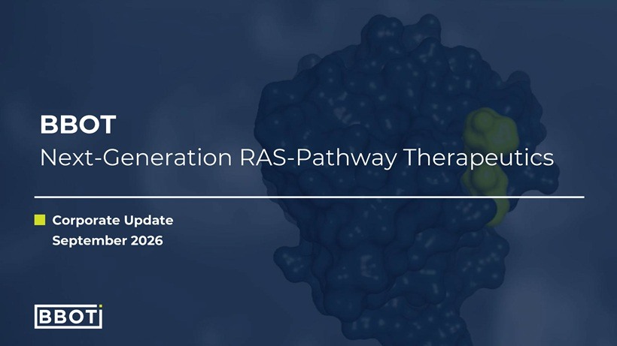
Corporate Update September 2026 BBOT Next-Generation RAS-Pathway Therapeutics

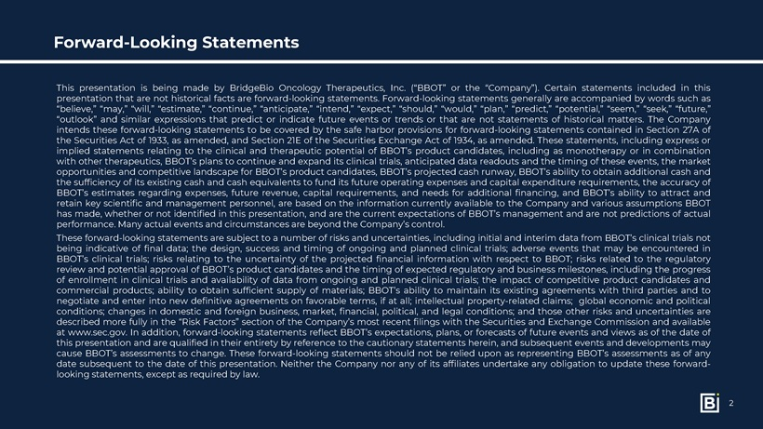
Forward-Looking Statements ThispresentationisbeingmadebyBridgeBioOncologyTherapeutics,Inc.(“BBOT”orthe“Company”).Certainstatementsincludedinthispresentationthatarenothistoricalfactsareforward-lookingstatements.Forward-lookingstatementsgenerallyareaccompaniedbywordssuchas“believe,”“may,”“will,”“estimate,”“continue,”“anticipate,”“intend,”“expect,”“should,”“would,”“plan,”“predict,”“potential,”“seem,”“seek,”“future,”“outlook”andsimilarexpressionsthatpredictorindicatefutureeventsortrendsorthatarenotstatementsofhistoricalmatters.TheCompanyintendstheseforward-lookingstatementstobecoveredbythesafeharborprovisionsforforward-lookingstatementscontainedinSection27AoftheSecuritiesActof1933,asamended,andSection21EoftheSecuritiesExchangeActof1934,asamended.Thesestatements,includingexpressorimpliedstatementsrelatingtotheclinicalandtherapeuticpotentialofBBOT’sproductcandidates,includingasmonotherapyorincombinationwithothertherapeutics,BBOT’splanstocontinueandexpanditsclinicaltrials,anticipateddatareadoutsandthetimingoftheseevents,themarketopportunitiesandcompetitivelandscapeforBBOT’sproductcandidates,BBOT’sprojectedcashrunway,BBOT’sabilitytoobtainadditionalcashandthesufficiencyofitsexistingcashandcashequivalentstofunditsfutureoperatingexpensesandcapitalexpenditurerequirements,theaccuracyofBBOT’sestimatesregardingexpenses,futurerevenue,capitalrequirements,andneedsforadditionalfinancing,andBBOT’sabilitytoattractandretainkeyscientificandmanagementpersonnel,arebasedontheinformationcurrentlyavailabletotheCompanyandvariousassumptionsBBOThasmade,whetherornotidentifiedinthispresentation,andarethecurrentexpectationsofBBOT’smanagementandarenotpredictionsofactualperformance.ManyactualeventsandcircumstancesarebeyondtheCompany’scontrol. Theseforward-lookingstatementsaresubjecttoanumberofrisksanduncertainties,includinginitialandinterimdatafromBBOT’sclinicaltrialsnotbeingindicativeoffinaldata;thedesign,successandtimingofongoingandplannedclinicaltrials;adverseeventsthatmaybeencounteredinBBOT’sclinicaltrials;risksrelatingtotheuncertaintyoftheprojectedfinancialinformationwithrespecttoBBOT;risksrelatedtotheregulatoryreviewandpotentialapprovalofBBOT’sproductcandidatesandthetimingofexpectedregulatoryandbusinessmilestones,includingtheprogressofenrollmentinclinicaltrialsandavailabilityofdatafromongoingandplannedclinicaltrials;theimpactofcompetitiveproductcandidatesandcommercialproducts;abilitytoobtainsufficientsupplyofmaterials;BBOT’sabilitytomaintainitsexistingagreementswiththirdpartiesandtonegotiateandenterintonewdefinitiveagreementsonfavorableterms,ifatall;intellectualproperty-relatedclaims;globaleconomicandpoliticalconditions;changesindomesticandforeignbusiness,market,financial,political,andlegalconditions;andthoseotherrisksanduncertaintiesaredescribedmorefullyinthe“RiskFactors”sectionoftheCompany’smostrecentfilingswiththeSecuritiesandExchangeCommissionandavailableatwww.sec.gov.Inaddition,forward-lookingstatementsreflectBBOT’sexpectations,plans,orforecastsoffutureeventsandviewsasofthedateofthispresentationandarequalifiedintheirentiretybyreferencetothecautionarystatementsherein,andsubsequenteventsanddevelopmentsmaycauseBBOT’sassessmentstochange.Theseforward-lookingstatementsshouldnotberelieduponasrepresentingBBOT’sassessmentsasofanydatesubsequenttothedateofthispresentation.NeithertheCompanynoranyofitsaffiliatesundertakeanyobligationtoupdatetheseforward-lookingstatements,exceptasrequiredbylaw. 2

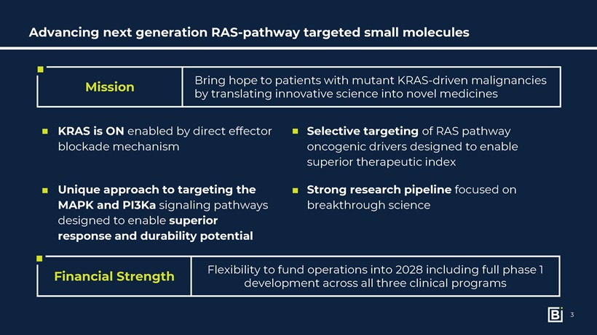
Advancing next generation RAS-pathway targeted small molecules Mission Strong research pipeline focused on breakthrough science Unique approach to targeting the MAPK and PI3Ka signaling pathways designed to enable superior response and durability potential Selective targeting of RAS pathway oncogenic drivers designed to enable superior therapeutic index KRAS is ON enabled by direct effector blockade mechanism Financial Strength Flexibility to fund operations into 2028 including full phase 1 development across all three clinical programs Bring hope to patients with mutant KRAS-driven malignancies by translating innovative science into novel medicines3

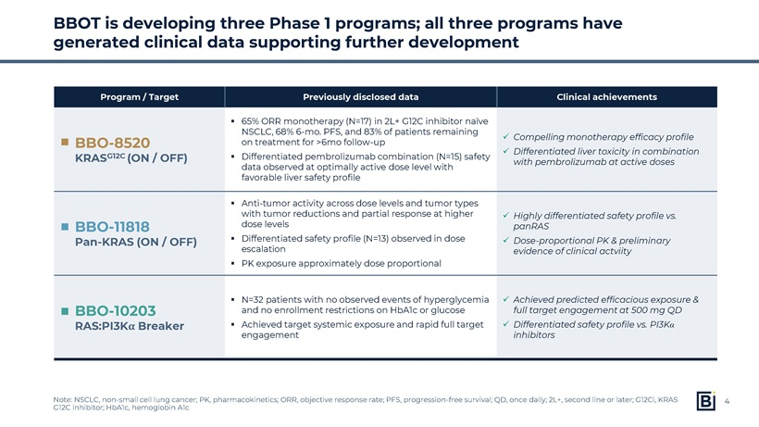
BBOT is developing three Phase 1 programs; all three programs have generated clinical data supporting further development Note: NSCLC, non-small cell lung cancer; PK, pharmacokinetics; ORR, objective response rate; PFS, progression-free survival; QD, once daily; 2L+, second line or later; G12Ci, KRAS G12C inhibitor; HbA1c, hemoglobin A1c Program / Target Previously disclosed data Clinical achievements BBO-8520 KRASG12C (ON / OFF) 65% ORR monotherapy (N=17) in 2L+ G12C inhibitor naïve NSCLC, 68% 6-mo. PFS, and 83% of patients remaining on treatment for >6mo follow-up Differentiated pembrolizumab combination (N=15) safety data observed at optimally active dose level with favorable liver safety profile Compelling monotherapy efficacy profile Differentiated liver toxicity in combination with pembrolizumab at active doses BBO-11818 Pan-KRAS (ON / OFF) Anti-tumor activity across dose levels and tumor types with tumor reductions and partial response at higher dose levels Differentiated safety profile (N=13) observed in dose escalation PK exposure approximately dose proportional Highly differentiated safety profile vs. panRAS Dose-proportional PK & preliminary evidence of clinical actviity BBO-10203 RAS:PI3KαBreaker N=32 patients with no observed events of hyperglycemia and no enrollment restrictions on HbA1c or glucose Achieved target systemic exposure and rapid full target engagement Achieved predicted efficacious exposure & full target engagement at 500 mg QD Differentiated safety profile vs. PI3Kα inhibitors

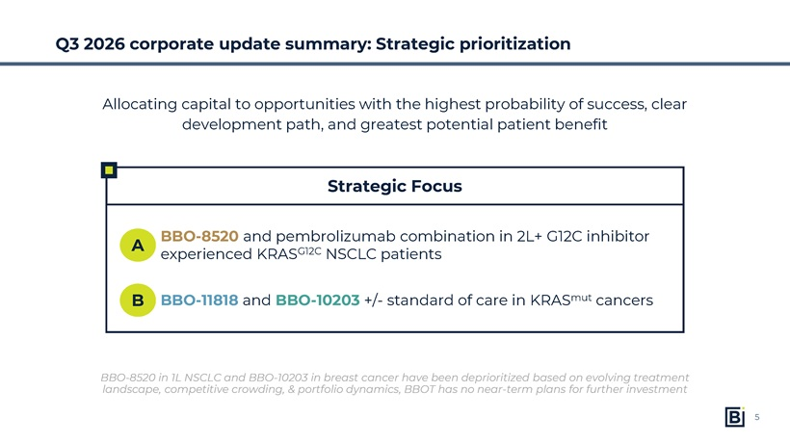
Strategic Focus Q3 2026 corporate update summary: Strategic prioritization BBO-8520 in 1L NSCLC and BBO-10203 in breast cancer have been deprioritized based on evolving treatment landscape, competitive crowding, & portfolio dynamics, BBOT has no near-term plans for further investment BBO-8520 and pembrolizumab combination in 2L+ G12C inhibitor experienced KRASG12C NSCLC patients A B Allocating capital to opportunities with the highest probability of success, clear development path, and greatest potential patient benefit BBO-11818 and BBO-10203 +/- standard of care in KRASmut cancers5

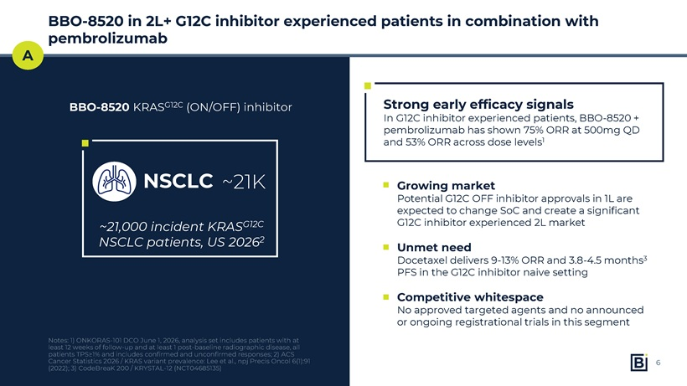
BBO-8520 in 2L+ G12C inhibitor experienced patients in combination with pembrolizumab Notes: 1) ONKORAS-101 DCO June 1, 2026, analysis set includes patients with at least 12 weeks of follow-up and at least 1 post-baseline radiographic disease, all patients TPS≥1%and includes confirmed and unconfirmed responses; 2) ACS Cancer Statistics2026 / KRAS variant prevalence: Lee et al., npjPrecisOncol6(1):91 (2022); 3) CodeBreaK 200 / KRYSTAL-12 (NCT04685135) Strong early efficacy signals In G12C inhibitor experienced patients, BBO-8520 + pembrolizumab has shown 75% ORR at 500mg QD and 53% ORR across dose levels1 ~21,000 incident KRASG12C NSCLC patients, US 20262 A Growing market Potential G12C OFF inhibitor approvals in 1L are expected to change SoC and create a significant G12C inhibitor experienced 2L market Unmet need Docetaxel delivers 9-13% ORR and 3.8-4.5 months3 PFS in the G12C inhibitor naive setting Competitive whitespace No approved targeted agents and no announced or ongoing registrational trials in this segment BBO-8520 KRASG12C (ON/OFF) inhibitor NSCLC ~21K6

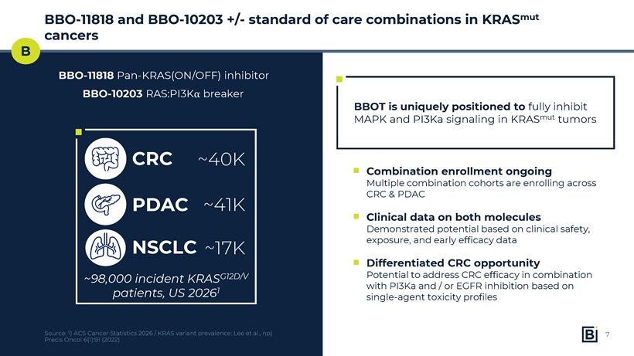
BBO-11818 and BBO-10203 +/- standard of care combinations in KRASmut cancers Source: 1) ACS Cancer Statistics2026 / KRAS variant prevalence: Lee et al., npjPrecisOncol6(1):91 (2022) BBOT is uniquely positioned to fully inhibit MAPK and PI3Ka signaling in KRASmut tumors ~98,000 incident KRASG12D/V patients, US 20261 B NSCLC Combination enrollment ongoing Multiple combination cohorts are enrolling across CRC & PDAC Clinical data on both molecules Demonstrated potential based on clinical safety, exposure, and early efficacy data Differentiated CRC opportunity Potential to address CRC efficacy in combination with PI3Ka and / or EGFR inhibition based on single-agent toxicity profiles BBO-11818 Pan-KRAS(ON/OFF) inhibitor BBO-10203 RAS:PI3Kα breaker CRC PDAC ~40K ~41K ~17K7

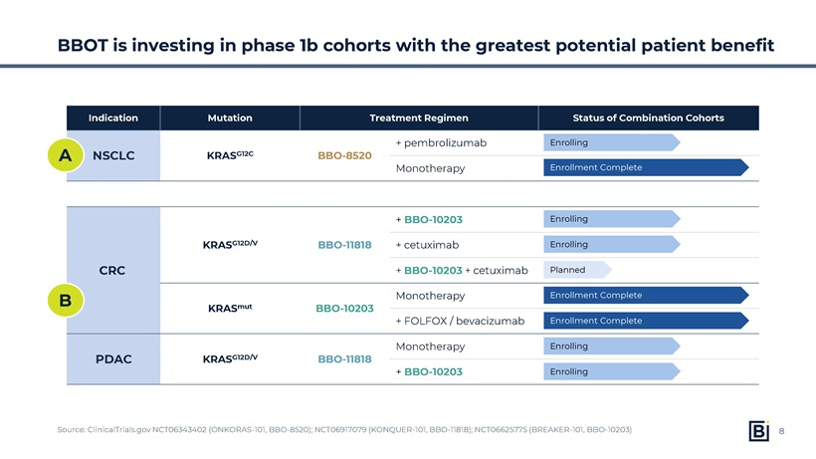
BBOT is investing in phase 1b cohorts with the greatest potential patient benefit Source: ClinicalTrials.gov NCT06343402 (ONKORAS-101, BBO-8520); NCT06917079 (KONQUER-101, BBO-11818); NCT06625775 (BREAKER-101, BBO-10203) Indication Mutation Treatment Regimen Status of Combination Cohorts NSCLC KRASG12C BBO-8520 + pembrolizumab Monotherapy CRC KRASG12D/V BBO-11818 + BBO-10203 + cetuximab + BBO-10203 + cetuximab KRASmut BBO-10203 Monotherapy + FOLFOX / bevacizumab PDAC KRASG12D/V BBO-11818 Monotherapy + BBO-10203

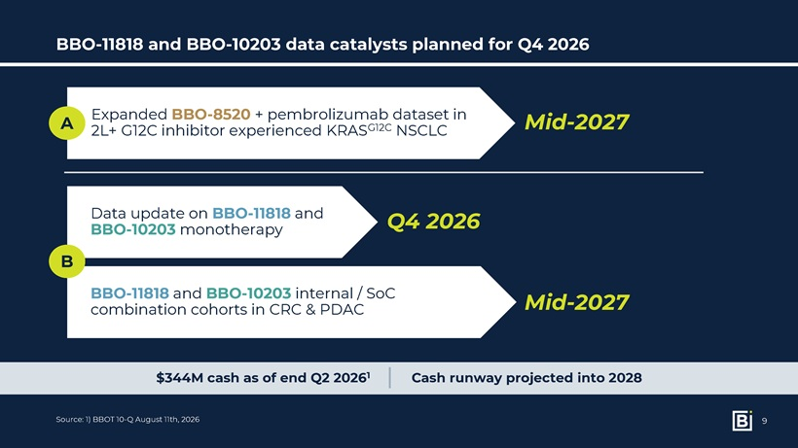
BBO-11818 and BBO-10203 data catalysts planned for Q4 2026 Source: 1) BBOT 10-Q August 11th, 2026 Mid-2027 Expanded BBO-8520 + pembrolizumab dataset in 2L+ G12C inhibitor experienced KRASG12C NSCLC $344M cash as of end Q2 20261 Cash runway projected into 2028 A Data update on BBO-11818 and BBO-10203 monotherapy BBO-11818 and BBO-10203 internal / SoC combination cohorts in CRC & PDAC Mid-2027 Q4 2026 B9

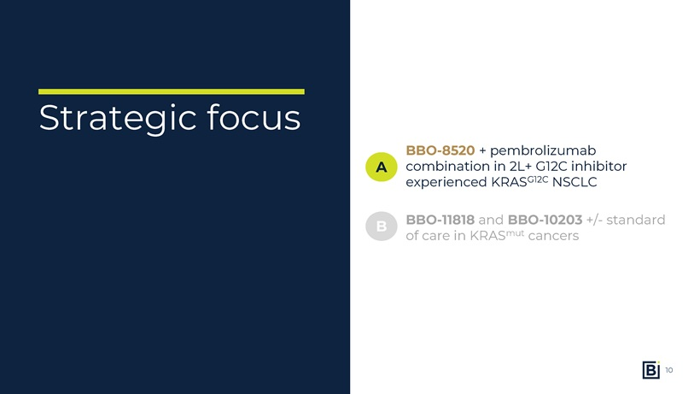
Strategic focus BBO-8520 + pembrolizumab combination in 2L+ G12C inhibitor experienced KRASG12C NSCLC A B BBO-11818 and BBO-10203 +/- standard of care in KRASmut cancers10

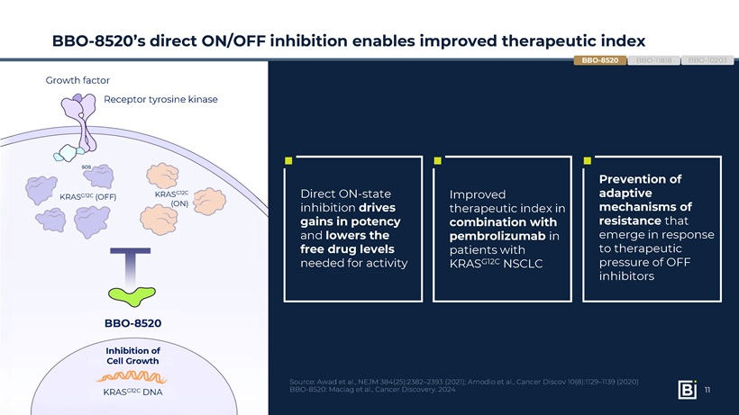
Direct ON-state inhibition drives gains in potency and lowers the free drug levels needed for activity Source: Awad et al., NEJM 384(25):2382–2393 (2021); Amodio et al., Cancer Discov 10(8):1129–1139 (2020) BBO-8520: Maciag et al., Cancer Discovery. 2024 Improved therapeutic index in combination with pembrolizumab in patients with KRASG12C NSCLC Prevention of adaptive mechanisms of resistance that emerge in response to therapeutic pressure of OFF inhibitors BBO-8520’s direct ON/OFF inhibition enables improved therapeutic index BBO-10203 BBO-8520 BBO-11818 BBO-8520 Growth factor Receptor tyrosine kinase KRASG12C DNA Inhibition of Cell Growth KRASG12C (OFF) KRASG12C (ON)11

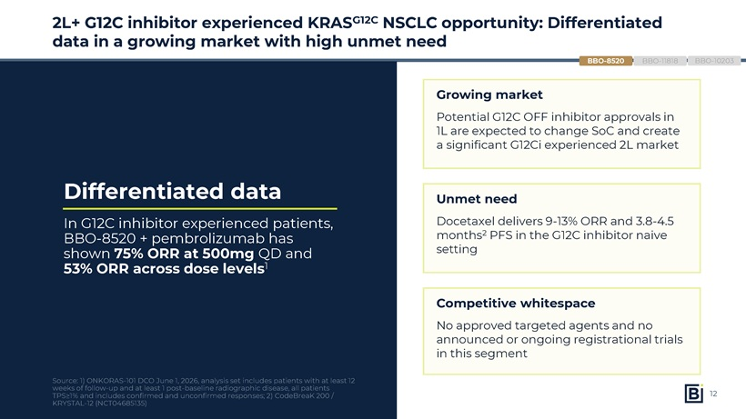
2L+ G12C inhibitor experienced KRASG12C NSCLC opportunity: Differentiated data in a growing market with high unmet need Differentiated data In G12C inhibitor experienced patients, BBO-8520 + pembrolizumab has shown 75% ORR at 500mg QD and 53% ORR across dose levels1 Source: 1) ONKORAS-101 DCO June 1, 2026, analysis set includes patients with at least 12 weeks of follow-up and at least 1 post-baseline radiographic disease, all patients TPS≥1%and includes confirmed and unconfirmed responses; 2) CodeBreaK 200 / KRYSTAL-12 (NCT04685135) BBO-10203 BBO-11818 Growing market Potential G12C OFF inhibitor approvals in 1L are expected to change SoC and create a significant G12Ci experienced 2L market Unmet need Docetaxel delivers 9-13% ORR and 3.8-4.5 months2 PFS in the G12C inhibitor naive setting Competitive whitespace No approved targeted agents and no announced or ongoing registrational trials in this segment BBO-852012

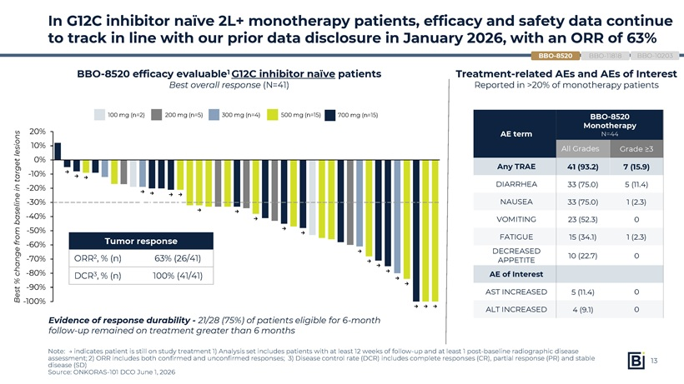
BBO-8520 efficacy evaluable1 G12C inhibitor naïve patients Best overall response (N=41) In G12C inhibitor naïve 2L+ monotherapy patients, efficacy and safety data continue to track in line with our prior data disclosure in January 2026, with an ORR of 63% Note: → indicates patient is still on study treatment 1) Analysis set includes patients with at least 12 weeks of follow-up and at least 1 post-baseline radiographic disease assessment; 2) ORR includes both confirmed and unconfirmed responses; 3) Disease control rate (DCR) includes complete responses (CR), partial response (PR) and stable disease (SD) Source: ONKORAS-101 DCO June 1, 2026 Best % change from baseline in target lesions 100 mg (n=2) 200 mg (n=5) 300 mg (n=4) 500 mg (n=15) 700 mg (n=15) → → → → → → → → → → → → → → → → → → → → → Treatment-related AEs and AEs of Interest Reported in >20% of monotherapy patientsAE term BBO-8520 Monotherapy N=44 All Grades Grade ≥3 Any TRAE 41 (93.2) 7 (15.9) DIARRHEA 33 (75.0) 5 (11.4) NAUSEA 33 (75.0) 1 (2.3) VOMITING 23 (52.3) 0 FATIGUE 15 (34.1) 1 (2.3) DECREASED APPETITE 10 (22.7) 0 AE of Interest AST INCREASED 5 (11.4) 0 ALT INCREASED 4 (9.1) 0

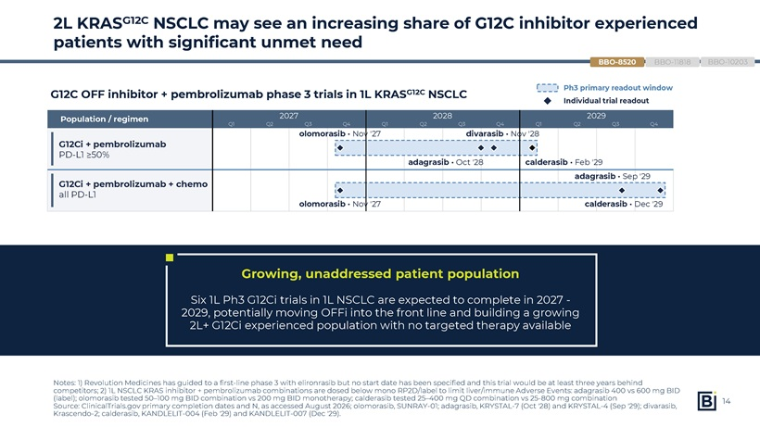
2L KRASG12C NSCLC may see an increasing share of G12C inhibitor experienced patients with significant unmet need Notes: 1) Revolution Medicines has guided to a first-line phase 3 with elironrasib but no start date has been specified and this trial would be at least three years behind competitors; 2) 1L NSCLC KRAS inhibitor + pembrolizumab combinations are dosed below mono RP2D/label to limit liver/immune Adverse Events: adagrasib 400 vs 600 mg BID (label); olomorasib tested 50–100 mg BID combination vs 200 mg BID monotherapy; calderasib tested 25–400 mg QD combination vs 25-800 mg combination Source: ClinicalTrials.gov primary completion dates and N, as accessed August 2026; olomorasib, SUNRAY-01; adagrasib, KRYSTAL-7 (Oct ‘28) and KRYSTAL-4 (Sep ‘29); divarasib, Krascendo-2; calderasib, KANDLELIT-004 (Feb ‘29) and KANDLELIT-007 (Dec ‘29). G12C OFF inhibitor + pembrolizumab phase 3 trials in 1L KRASG12C NSCLC Growing, unaddressed patient population Six 1L Ph3 G12Ci trials in 1L NSCLC are expected to complete in 2027—2029, potentially moving OFFi into the front line and building a growing 2L+ G12Ci experienced population with no targeted therapy available Ph3 primary readout window Individual trial readout Population / regimen 2027 2028 2029 G12Ci + pembrolizumab PD-L1 ≥50% G12Ci + pembrolizumab+ chemo all PD-L1 olomorasib · Nov ‘27 divarasib · Nov ‘28 adagrasib · Oct ‘28 calderasib · Feb ‘29 adagrasib · Sep ‘29 olomorasib · Nov ‘27 calderasib · Dec ‘29 Q1 Q2 Q3 Q4 Q1 Q2 Q3 Q4 Q1 Q2 Q3 Q4 BBO-10203 BBO-11818 BBO-852014

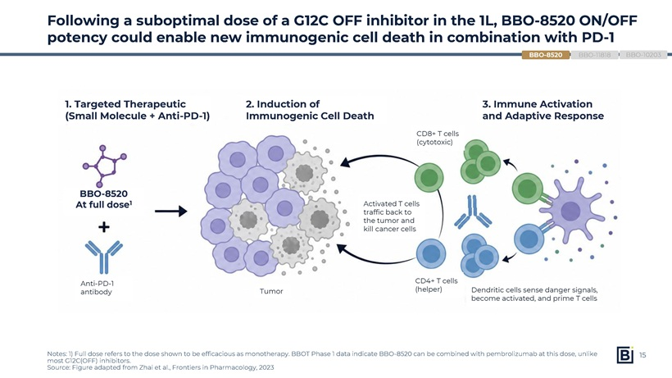
Following a suboptimal dose of a G12C OFF inhibitor in the 1L, BBO-8520 ON/OFF potency could enable new immunogenic cell death in combination with PD-1 BBO-8520 At full dose1 1. Targeted Therapeutic(Small Molecule + Anti-PD-1) 2. Induction ofImmunogenic Cell Death 3. Immune Activationand Adaptive Response CD8+ T cells(cytotoxic) Activated T cellstraffic back tothe tumor andkill cancer cells CD4+ T cells(helper) Dendritic cells sense danger signals,become activated, and prime T cells Anti-PD-1antibody Tumor Notes: 1) Full dose refers to the dose shown to be efficacious as monotherapy. BBOT Phase 1 data indicate BBO-8520 can be combined with pembrolizumab at this dose, unlike most G12C(OFF) inhibitors. Source: Figure adapted from Zhai et al., Frontiers in Pharmacology, 2023 BBO-10203 BBO-11818 BBO-852015

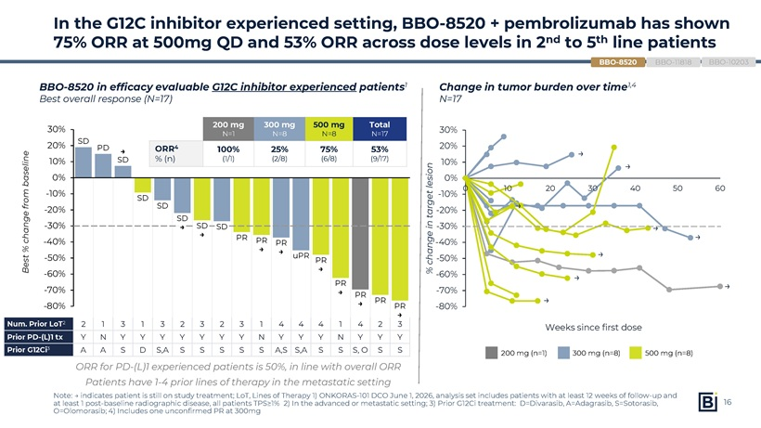
In the G12C inhibitor experienced setting, BBO-8520 + pembrolizumab has shown 75% ORR at 500mg QD and 53% ORR across dose levels in 2nd to 5th line patients Note: → indicates patient is still on study treatment; LoT, Lines of Therapy 1) ONKORAS-101 DCO June 1, 2026, analysis set includes patients with at least 12 weeks of follow-up and at least 1 post-baseline radiographic disease, all patients TPS≥1% 2) In the advanced or metastatic setting; 3) Prior G12Ci treatment: D=Divarasib, A=Adagrasib, S=Sotorasib, O=Olomorasib; 4) Includes one unconfirmed PR at 300mg BBO-8520 in efficacy evaluable G12C inhibitor experienced patients1 Best overall response (N=17) 200 mg (n=1) 300 mg (n=8) 500 mg (n=8) → → → → → → → → → Best % change from baseline SD PD → SD SD SD SD → SD → SD PR PR → PR → uPR PR → PR → PR → PR PR →200 mg N=1 300 mg N=8 500 mg N=8 Total N=17 ORR4 % (n) 100% (1/1) 25% (2/8) 75% (6/8) 53% (9/17)

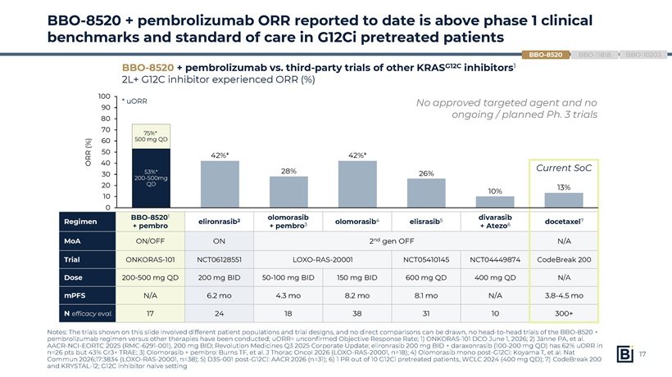
BBO-8520 + pembrolizumab ORR reported to date is above phase 1 clinical benchmarks and standard of care in G12Ci pretreated patients Notes: The trials shown on this slide involved different patient populations and trial designs, and no direct comparisons can be drawn, no head-to-head trials of the BBO-8520 + pembrolizumab regimen versus other therapies have been conducted; uORR= unconfirmedObjective ResponseRate; 1) ONKORAS-101 DCO June 1, 2026; 2) Jänne PA, et al. AACR-NCI-EORTC 2025 (RMC-6291-001), 200 mg BID; Revolution Medicines Q3 2025 Corporate Update; elironrasib 200 mg BID + daraxonrasib (100-200 mg QD) has 62% uORR in n=26 pts but 43% Gr3+ TRAE; 3) Olomorasib + pembro: Burns TF, et al. J Thorac Oncol 2026 (LOXO-RAS-20001, n=18); 4) Olomorasib mono post-G12Ci: Koyama T, et al. Nat Commun 2026;17:3834 (LOXO-RAS-20001, n=38); 5) D3S-001 post-G12Ci: AACR 2026 (n=31); 6) 1 PR out of 10 G12Ci pretreated patients, WCLC 2024 (400 mg QD); 7) CodeBreak 200 and KRYSTAL-12; G12C inhibitor naïve setting Regimen BBO-85201 + pembro elironrasib2 olomorasib + pembro3 olomorasib4 elisrasib5 divarasib + Atezo6 docetaxel7 MoA ON/OFF ON 2nd gen OFF N/A Trial ONKORAS-101 NCT06128551 LOXO-RAS-20001 NCT05410145 NCT04449874 CodeBreak 200 Dose 200-500 mg QD 200 mg BID 50-100 mg BID 150 mg BID 600 mg QD 400 mg QD N/A mPFS N/A 6.2 mo 4.3 mo 8.2 mo 8.1 mo N/A 3.8-4.5 mo N efficacy eval. 17 24 18 38 31 10 300+

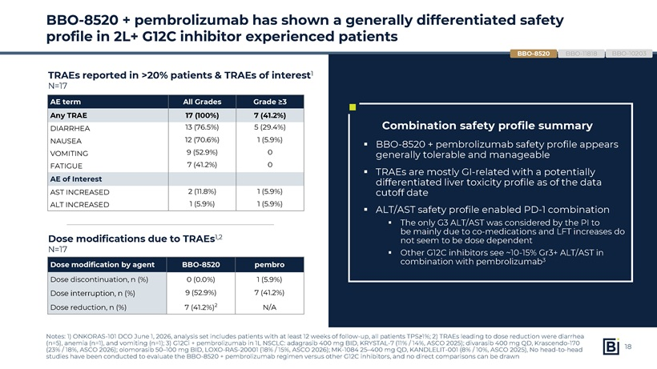
BBO-8520 + pembrolizumab has shown a generally differentiated safety profile in 2L+ G12C inhibitor experienced patients BBO-8520 + pembrolizumab safety profile appears generallytolerable and manageable TRAEs are mostly GI-related with a potentially differentiated liver toxicity profile as of the data cutoff date ALT/AST safety profile enabled PD-1 combinationThe only G3 ALT/AST was considered by the PI to bemainly due to co-medications and LFT increases do not seem to be dose dependent Other G12C inhibitors see ~10-15% Gr3+ ALT/AST in combination with pembrolizumab3 Notes: 1) ONKORAS-101 DCO June 1, 2026, analysis set includes patients with at least 12 weeks of follow-up, all patients TPS≥1%; 2) TRAEs leading to dose reduction were diarrhea (n=5), anemia (n=1), and vomiting (n=1); 3) G12Ci + pembrolizumab in 1L NSCLC: adagrasib 400 mg BID, KRYSTAL-7 (11% / 14%, ASCO 2025); divarasib 400 mg QD, Krascendo-170 (23% / 18%, ASCO 2026); olomorasib 50–100 mg BID, LOXO-RAS-20001 (18% / 15%, ASCO 2026); MK-1084 25–400 mg QD, KANDLELIT-001 (8% / 10%, ASCO 2025), No head-to-head studies have been conducted to evaluate the BBO-8520 + pembrolizumab regimen versus other G12C inhibitors, and no direct comparisons can be drawnAE term All Grades Grade ≥3 Any TRAE 17 (100%) 7 (41.2%) DIARRHEA 13 (76.5%) 5 (29.4%) NAUSEA 12 (70.6%) 1 (5.9%) VOMITING 9 (52.9%) 0 FATIGUE 7 (41.2%) 0 AE of Interest AST INCREASED 2 (11.8%) 1 (5.9%) ALT INCREASED 1 (5.9%) 1 (5.9%)

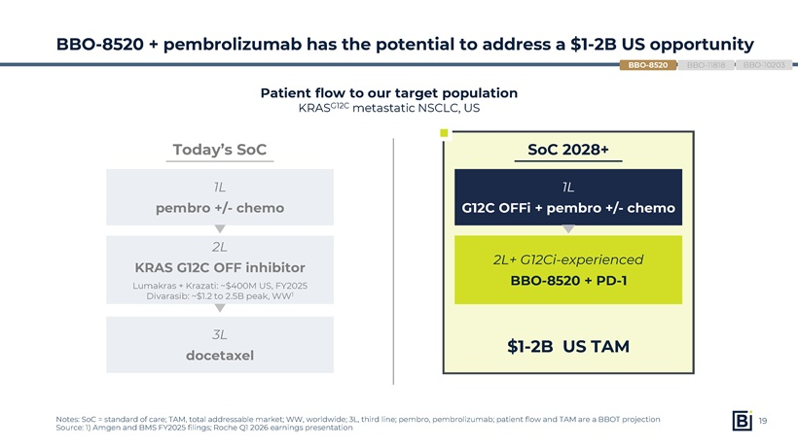
$1-2B US TAM Today’s SoC SoC 2028+ 1L pembro +/- chemo 1L G12C OFFi + pembro +/- chemo 2L KRAS G12C OFF inhibitor Lumakras + Krazati: ~$400M US, FY2025 Divarasib: ~$1.2 to 2.5B peak, WW1 2L+ G12Ci-experienced BBO-8520 + PD-1 3L docetaxel BBO-8520 + pembrolizumab has the potential to address a $1-2B US opportunity Notes: SoC = standard of care; TAM, total addressable market; WW, worldwide; 3L, third line; pembro, pembrolizumab; patient flow and TAM are a BBOT projection Source: 1) Amgen and BMS FY2025 filings; Roche Q1 2026 earnings presentation Patient flow to our target population KRASG12C metastatic NSCLC, US BBO-10203 BBO-11818 BBO-852019

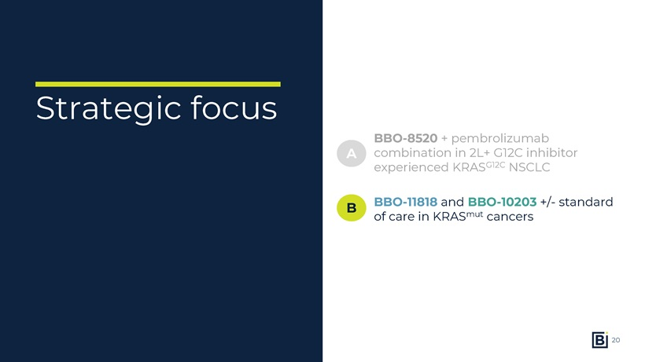
Strategic focus BBO-8520 + pembrolizumab combination in 2L+ G12C inhibitor experienced KRASG12C NSCLC A B BBO-11818 and BBO-10203 +/- standard of care in KRASmut cancers20

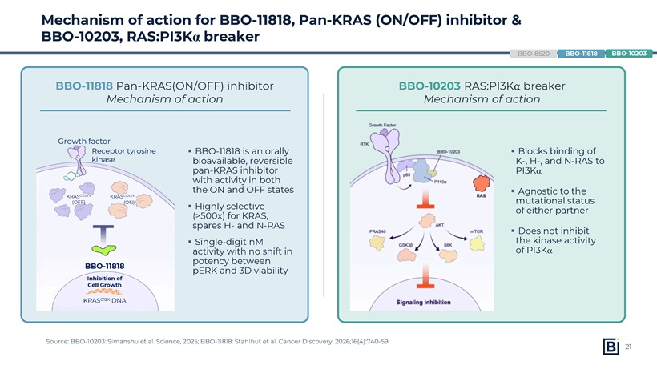
Mechanism of action for BBO-11818, Pan-KRAS (ON/OFF) inhibitor & BBO-10203, RAS:PI3Kα breaker Source: BBO-10203: Simanshu et al. Science, 2025; BBO-11818: Stahlhut et al. Cancer Discovery, 2026;16(4):740-59 BBO-11818 is an orally bioavailable, reversible pan-KRAS inhibitor with activity in both the ON and OFF states Highly selective (>500x) for KRAS, spares H- and N-RAS Single-digit nM activity with no shift in potency between pERK and 3D viability BBO-11818 Pan-KRAS(ON/OFF) inhibitor Mechanism of action BBO-8520 BBO-10203 BBO-11818 BBO-11818 Growth factor Receptor tyrosine kinase KRASG12X DNA Inhibition of Cell Growth KRASG12D/V (OFF) KRASG12D/V (ON) Blocks binding of K-, H-, and N-RAS to PI3K Agnostic to the mutational status of either partner Does not inhibit the kinase activity of PI3K BBO-10203 RAS:PI3Kα breaker Mechanism of action21

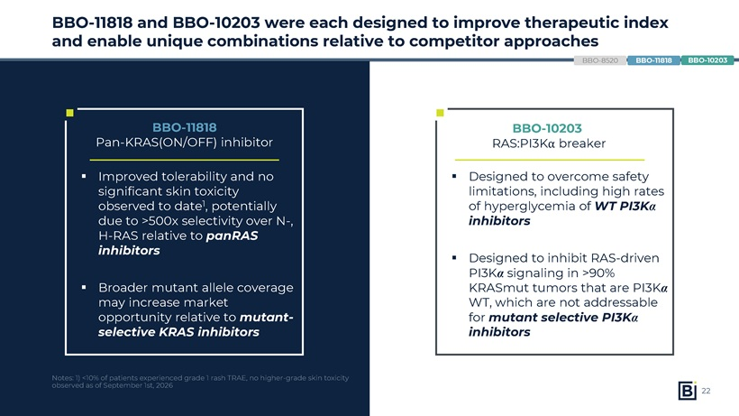
BBO-11818 and BBO-10203 were each designed to improve therapeutic index and enable unique combinations relative to competitor approaches BBO-8520 BBO-10203 RAS:PI3K breaker BBO-11818 Pan-KRAS(ON/OFF) inhibitor Improved tolerability and no significant skin toxicity observed to date1, potentially due to >500x selectivity over N-, H-RAS relative to panRAS inhibitors Broader mutant allele coverage may increase market opportunity relative to mutant-selective KRAS inhibitors Designed to overcome safety limitations, including high rates of hyperglycemia of WT PI3K inhibitors Designed to inhibit RAS-driven PI3K signaling in >90% KRASmut tumors that are PI3K WT, which are not addressable for mutant selective PI3K inhibitors BBO-10203 BBO-11818 Notes: 1) <10% of patients experienced grade 1 rash TRAE, no higher-grade skin toxicity observed as of September 1st, 202622

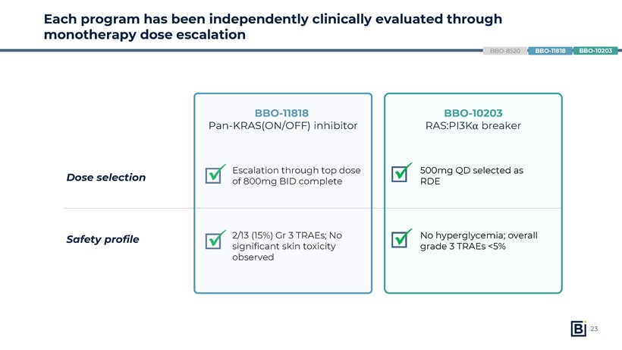
Each program has been independently clinically evaluated through monotherapy dose escalation BBO-8520 BBO-10203 RAS:PI3Kα breakerDose selection Safety profile

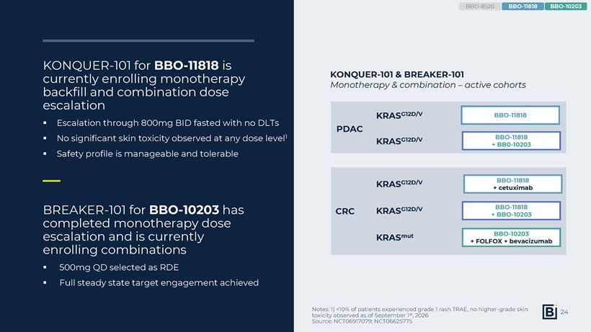
KONQUER-101 for BBO-11818 is currently enrolling monotherapy backfill and combination dose escalation Escalation through 800mg BID fasted with no DLTs No significant skin toxicity observed at any dose level1 Safety profile is manageable and tolerable Notes: 1) <10% of patients experienced grade 1 rash TRAE, no higher-grade skin toxicity observed as of September 1st, 2026 Source: NCT06917079; NCT06625775 KONQUER-101 & BREAKER-101 Monotherapy & combination – active cohorts BBO-11818 + BBO-10203 BBO-11818 + BB0-10203 KRASG12D/V KRASG12D/V KRASmut BBO-10203 + FOLFOX + bevacizumab BBO-11818 + cetuximab KRASG12D/V BBO-11818 KRASG12D/V BREAKER-101 for BBO-10203 has completed monotherapy dose escalation and is currently enrolling combinations 500mg QD selected as RDE Full steady state target engagement achieved CRC PDAC BBO-8520 BBO-10203 BBO-1181824

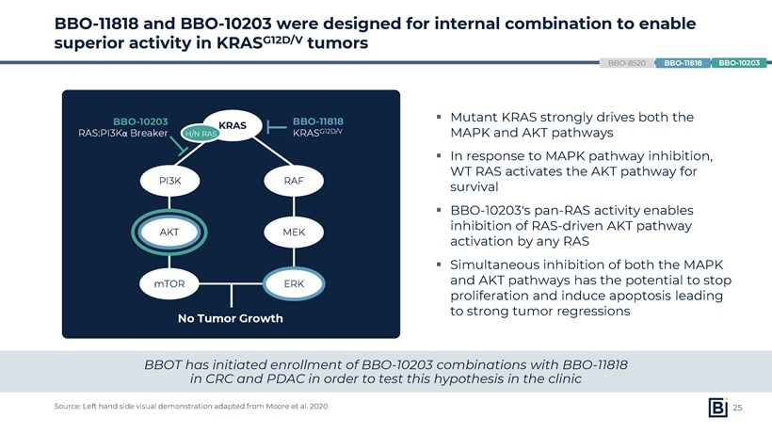
BBO-11818 and BBO-10203 were designed for internal combination to enable superior activity in KRASG12D/V tumors Source: Left hand side visual demonstration adapted from Moore et al. 2020 Mutant KRAS strongly drives both the MAPK andAKT pathways In response to MAPK pathway inhibition, WT RAS activates theAKT pathway for survival BBO-10203’s pan-RAS activity enables inhibition of RAS-drivenAKT pathway activation by any RAS Simultaneous inhibition of both the MAPK andAKT pathwayshas the potential to stop proliferation and induce apoptosisleading tostrong tumor regressions BBO-8520 BBO-10203 RAS:PI3Kα Breaker KRAS PI3K AKT RAF MEK mTOR No Tumor Growth BBO-11818 KRASG12D/V ERK H/N RAS BBOT has initiated enrollment of BBO-10203 combinations with BBO-11818 in CRC and PDAC in order to test this hypothesis in the clinic BBO-10203 BBO-1181825

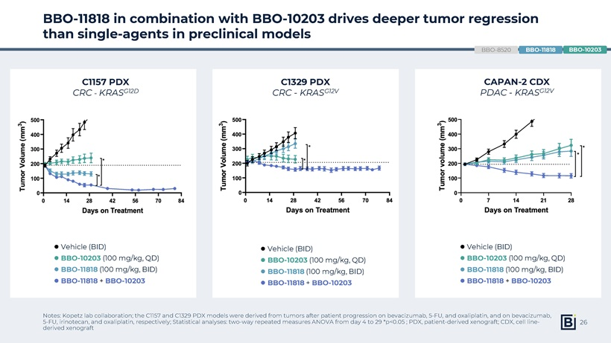
BBO-11818 in combination with BBO-10203 drives deeper tumor regression than single-agents in preclinical models C1157 PDX CRC-KRASG12D C1329 PDX CRC -KRASG12V Vehicle (BID) BBO-11818 (100 mg/kg, BID) BBO-10203 (100 mg/kg, QD) BBO-11818 + BBO-10203 Vehicle (BID) BBO-11818 (100 mg/kg, BID) BBO-10203 (100 mg/kg, QD) BBO-11818 + BBO-10203 Vehicle (BID) BBO-11818 (100 mg/kg, BID) BBO-10203 (100 mg/kg, QD) BBO-11818 + BBO-10203 CAPAN-2 CDX PDAC -KRASG12V BBO-8520 Notes: Kopetz lab collaboration; the C1157 and C1329 PDX models were derived from tumors after patient progression on bevacizumab, 5-FU, and oxaliplatin, and on bevacizumab, 5-FU, irinotecan, and oxaliplatin, respectively; Statistical analyses: two-way repeated measures ANOVA from day 4 to 29 *p<0.05 ; PDX, patient-derived xenograft; CDX, cell line-derived xenograft BBO-10203 BBO-1181826

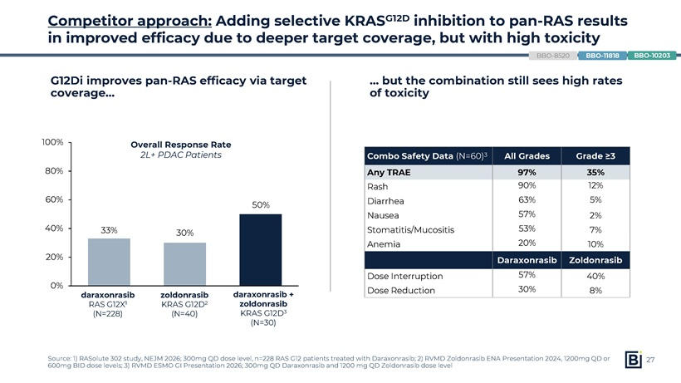
but the combination still sees high rates of toxicity Competitor approach: Adding selective KRASG12D inhibition to pan-RAS results in improved efficacy due to deeper target coverage, but with high toxicity G12Di improves pan-RAS efficacy via target coverage Combo Safety Data (N=60)3 All Grades Grade ≥3 Any TRAE 97% 35% Rash 90% 12% Diarrhea 63% 5% Nausea 57% 2% Stomatitis/Mucositis 53% 7% Anemia 20% 10% Daraxonrasib Zoldonrasib Dose Interruption 57% 40% Dose Reduction 30% 8%

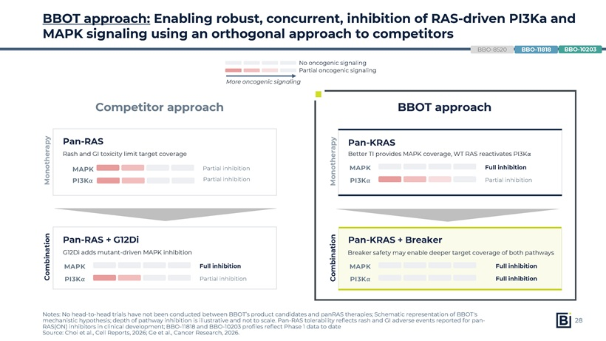
BBOT approach: Enabling robust, concurrent, inhibition of RAS-driven PI3Ka and MAPK signaling using an orthogonal approach to competitors Notes: No head-to-head trials have not been conducted between BBOT’s product candidates and panRAS therapies; Schematic representation of BBOT’s mechanistic hypothesis; depth of pathway inhibition is illustrative and not to scale. Pan-RAS tolerability reflects rash and GI adverse events reported for pan-RAS(ON) inhibitors in clinical development; BBO-11818 and BBO-10203 profiles reflect Phase 1 data to date Source: Choi et al., Cell Reports, 2026; Ge et al., Cancer Research, 2026. No oncogenic signaling Partial oncogenic signaling More oncogenic signaling Monotherapy Combination Pan-RAS Rash and GI toxicity limit target coverage MAPK PI3Kα Partial inhibition Pan-KRAS Better TI provides MAPK coverage, WT RAS reactivates PI3Kα MAPK Full inhibition PI3Kα Partial inhibition Pan-RAS + G12Di G12Di adds mutant-driven MAPK inhibition MAPK Full inhibition PI3Kα Partial inhibition Pan-KRAS + Breaker Breaker safety may enable deeper target coverage of both pathways MAPK Full inhibition PI3Kα Full inhibition Competitor approach Partial inhibition Monotherapy Combination BBOT approach BBO-8520 BBO-10203 BBO-1181828

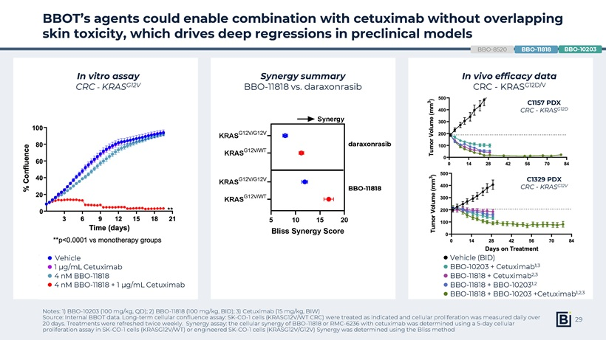
BBOT’s agents could enable combination with cetuximab without overlapping skin toxicity, which drives deep regressions in preclinical models Notes: 1) BBO-10203 (100 mg/kg, QD); 2) BBO-11818 (100 mg/kg, BID); 3) Cetuximab (15 mg/kg, BIW) Source: Internal BBOT data. Long-term cellular confluence assay: SK-CO-1 cells (KRASG12V/WT CRC) were treated as indicated and cellular proliferation was measured daily over 20 days. Treatments were refreshed twice weekly. Synergy assay: the cellular synergy of BBO-11818 or RMC-6236 with cetuximab was determined using a 5-day cellular proliferation assay in SK-CO-1 cells (KRASG12V/WT) or engineered SK-CO-1 cells (KRASG12V/G12V) Synergy was determined using the Bliss method In vitro assay CRC—KRASG12V Synergy summary BBO-11818 vs. daraxonrasib In vivo efficacy data CRC—KRASG12D/V 5 10 15 20 KRASG12V/WT KRASG12V/G12V KRASG12V/WT KRASG12V/G12V Bliss Synergy Score BBO-11818 Synergy RMC-6236 C1329 PDX CRC—KRASG12V C1157 PDX CRC—KRASG12D BBO-8520 BBO-10203 BBO-11818  Vehicle  4 nM BBO-11818  1 µg/mL Cetuximab  4 nM BBO-11818 + 1 µg/mL Cetuximab  Vehicle (BID)  BBO-11818 + BBO-102031,2  BBO-11818 + Cetuximab2,3  BBO-10203 + Cetuximab1,3  BBO-11818 + BBO-10203 +Cetuximab1,2,3 daraxonrasib BBO-1181829

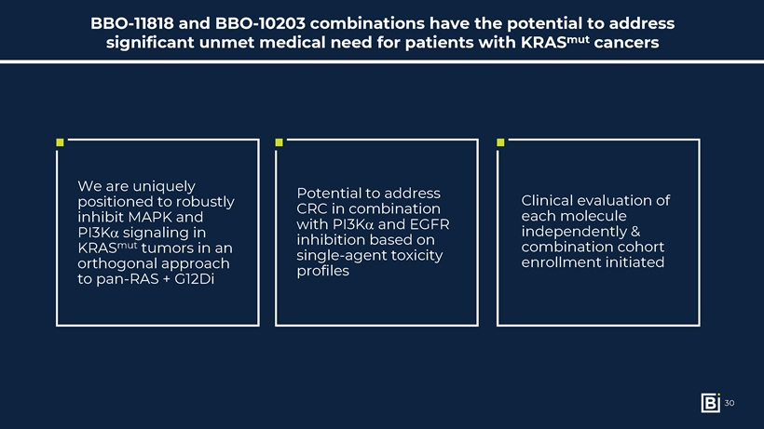
BBO-11818 and BBO-10203 combinations have the potential to address significant unmet medical need for patients with KRASmut cancers Potential to address CRC in combination with PI3K and EGFR inhibition based on single-agent toxicity profiles We are uniquely positioned to robustly inhibit MAPK and PI3K signaling in KRASmut tumors in an orthogonal approach to pan-RAS + G12Di Clinical evaluation of each molecule independently & combination cohort enrollment initiated30

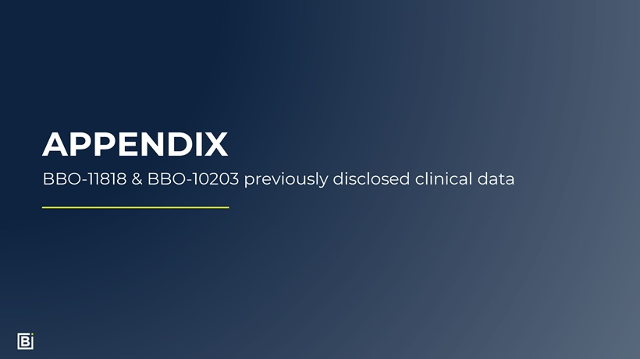
APPENDIX BBO-11818 & BBO-10203 previously disclosed clinical data

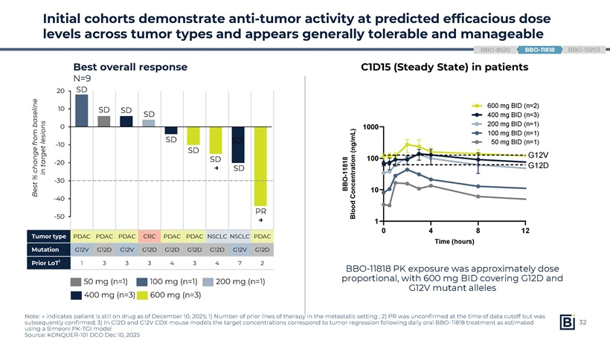
Initial cohorts demonstrate anti-tumor activity at predicted efficacious dose levels across tumor types and appears generally tolerable and manageable BBO-8520 BBO-11818 BBO-10203 Best overall response N=9 20 SD 10 SD SD baseline SD 0 from lesions SD SD -10 get SD tar -20 SD change → SD % in Best -30 -40 PR -50 → Tumor type PDAC PDAC PDAC CRC PDAC PDAC NSCLC NSCLC PDAC Mutation G12V G12D G12V G12D G12D G12D G12D G12V G12D Prior LoT1 1 3 3 3 4 3 4 7 2 50 mg (n=1) 100 mg (n=1) 200 mg (n=1) 400 mg (n=3) 600 mg (n=3) C1D15 (Steady State) in patients 600 mg BID (n=2) 400 mg BID (n=3) 1000 200 mg BID (n=1) L ) 100 mg BID (n=1) /m g 50 mg BID (n=1) ( n n 100 G12V 818 io G12D 1 1 rat—nt BBO c e Con 10 Blood 1 0 4 8 12 Time (hours) BBO-11818 PK exposure was approximately dose proportional, with 600 mg BID covering G12D and G12V mutant alleles Note: → indicates patient is still on drug as of December 10, 2025; 1) Number of prior lines of therapy in the metastatic setting ; 2) PR was unconfirmed at the time of data cutoff but was subsequently confirmed; 3) In G12D and G12V CDX mouse models the target concentrations correspond to tumor regression following daily oral BBO-11818 treatment as estimated using a Simeoni PK-TGI model Source: KONQUER-101 DCO Dec 10, 2025 32

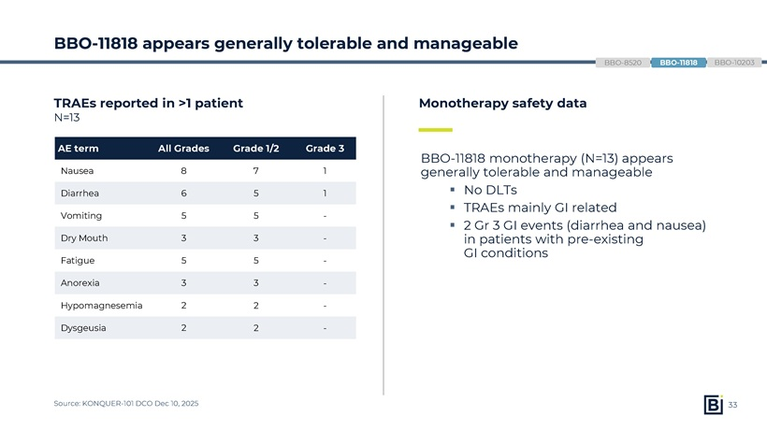
BBO-11818 appears generally tolerable and manageable TRAEs reported in >1 patient N=13 AE term All Grades Grade 1/2 Grade 3 Nausea 8 7 1 Diarrhea 6 5 1 Vomiting 5 5 -Dry Mouth 3 3 -Fatigue 5 5 -Anorexia 3 3 -Hypomagnesemia 2 2 -Dysgeusia 2 2— Monotherapy safety data BBO-11818 monotherapy (N=13) appears generally tolerable and manageable ▪ No DLTs ▪ TRAEs mainly GI related ▪ 2 Gr 3 GI events (diarrhea and nausea) in patients with pre-existing GI conditions Source: KONQUER-101 DCO Dec 10, 2025 33

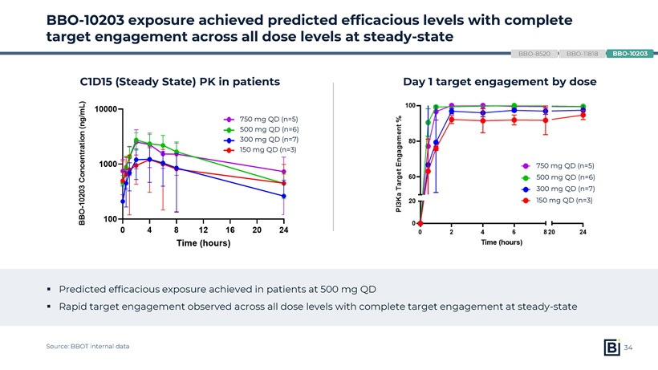
BBO-10203 exposure achieved predicted efficacious levels with complete target engagement across all dose levels at steady-state BBO-8520 BBO-11818 BBO-10203 C1D15 (Steady State) PK in patients 750 mg QD (n=5) 500 mg QD (n=6) 300 mg QD (n=7) 150 mg QD (n=3) Day 1 target engagement by dose 750 mg QD (n=5) 500 mg QD (n=6) 300 mg QD (n=7) 150 mg QD (n=3) ▪ Predicted efficacious exposure achieved in patients at 500 mg QD ▪ Rapid target engagement observed across all dose levels with complete target engagement at steady-state Source: BBOT internal data 34

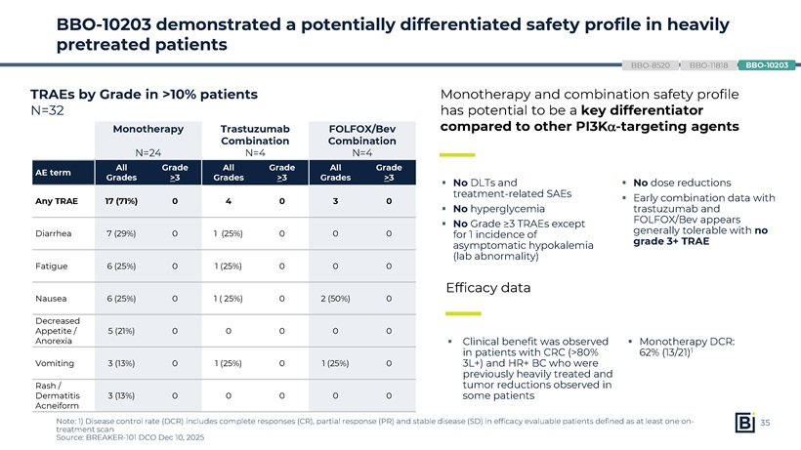
BBO-10203 demonstrated a potentially differentiated safety profile in heavily pretreated patients BBO-8520 BBO-11818 BBO-10203 TRAEs by Grade in >10% patients N=32 Monotherapy Trastuzumab FOLFOX/Bev Combination Combination N=24 N=4 N=4 All Grade All Grade All Grade AE term Grades >3 Grades >3 Grades >3 Any TRAE 17 (71%) 0 4 0 3 0 Diarrhea 7 (29%) 0 1 (25%) 0 0 0 Fatigue 6 (25%) 0 1 (25%) 0 0 0 Nausea 6 (25%) 0 1 ( 25%) 0 2 (50%) 0 Decreased Appetite / 5 (21%) 0 0 0 0 0 Anorexia Vomiting 3 (13%) 0 1 (25%) 0 1 (25%) 0 Rash / Dermatitis 3 (13%) 0 0 0 0 0 Acneiform Monotherapy and combination safety profile has potential to be a key differentiator compared to other PI3K-targeting agents ▪ No DLTs and ▪ No dose reductions treatment-related SAEs ▪ Early combination data with ▪ No hyperglycemia trastuzumab and ▪ No Grade ≥3 TRAEs except FOLFOX/Bev appears for 1 incidence of generally tolerable with no asymptomatic hypokalemia grade 3+ TRAE (lab abnormality) Efficacy data ▪ Clinical benefit was observed ▪ Monotherapy DCR: in patients with CRC (>80% 62% (13/21)1 3L+) and HR+ BC who were previously heavily treated and tumor reductions observed in some patients Note: 1) Disease control rate (DCR) includes complete responses (CR), partial response (PR) and stable disease (SD) in efficacy evaluable patients defined as at least one on- 35 treatment scan Source: BREAKER-101 DCO Dec 10, 2025

